

Mid Term EXAM (30 Marks)

Section -A (5*1 =5)
Select the correct option(s) for the following questions

- What is the full form of Devops?
- Development And Operations
- Digital and Operations
- Drive and Operations
- None of the above
Ans - A

- What are the key components of Devops?
- Continuous Integration
- Continuous Testing
- Continuous Delivery & Monitoring
- All of the above
Ans -D

- Who is known as the father of DevOps?
- Walter Dandy
- Patrick Debois
- Liam Debois
- None of these

Ans - B

- Select the PRIMARY stakeholders for DevOps?
- Testers
- Design Engineers
- Quality Assurance
- All of the above
Ans -D

- What do you mean by Jenkins?
- Jenkins is an open source Continuous and Integration.
- Jenkins is an open source Continuous Integration and Continuous Delivery Tool.
- Jenkins is an open source Continuous and only Continuous Delivery Tool.
- None of these
Ans - B

Section – B (5*1 = 5)
Select True or False for the following questions
- DevOps does not enable you to quickly identify, fix and learn from errors
- True
- False
Ans - False

- The goal of DevOps is to establish an environment where the release of applications is valued more than its quality
- True
- False
And - False

- DevOps and Agile can be replaced with each other
- True
- False
Ans - False

- It is possible to get feedback from customers much earlier, with DevOps model
- True
- False
Ans – True

- Jenkins cannot be launched through a browser
- True
- False
Ans - False

Section – C (5*2 = 10)
Explain in 2 sentences for the following question

1. Explain what is DevOps?

DevOps is a set of practices that combines software development and IT operations. It aims to shorten the systems development life cycle and provide continuous delivery with high software quality.

2. Mention the advantages of DevOps in business.
DevOps encourage faster, better, and more secure delivery of business value to any organization. The DevOps value can take the form of product releases, updates, and features. It involves quick product release with an outstanding level of security.

3. Mention the phases of DevOps Lifecycle

DevOps include seven Lifecyle phases

1. Continuous Development

2. Continuous Integration

3 Continuous Testing

4. Continuous Monitoring

5. Continuous Feedback

6. Continuous Deployment

7. Continuous Operations

4. Explain Continuous Integration (CI)
Continuous integration (CI) is the practice of automating the integration of code changes from multiple contributors into a single software project. It's a primary DevOps best practice, allowing developers to frequently merge code changes into a central repository where builds and tests then run.

5. Mention 2 advantages and disadvantages of Jenkins
Advantages of Jenkins
1 . It is an open-source tool with great community support.
2 . It is an open-source tool with great community support.

Disadvantages of Jenkins
1 Jenkins has a lot of redundant plugins.
2. It does not allow the tailoring of the workflow processes, reporting, managing security changes, and extensions to the base application to meet the customer's needs

Section – D (1*10 = 10)
Explain in detail for any one of the following questions
- Explain the architecture of Jenkins with a diagram
(or)
- Explain the architecture of DevOps with a diagram

Ans 2 - DevOps architecture is used for the applications hosted on the cloud platform and large distributed applications. Agile Development is used in the DevOps architecture so that integration and delivery can be contiguous. When the development and operations team works separately from each other, then it is time-consuming to design, test, and deploy. And if the terms are not in sync with each other, then it may cause a delay in the delivery. So DevOps enables the teams to change their shortcomings and increases productivity.

Below are the various components that are used in the DevOps architecture:

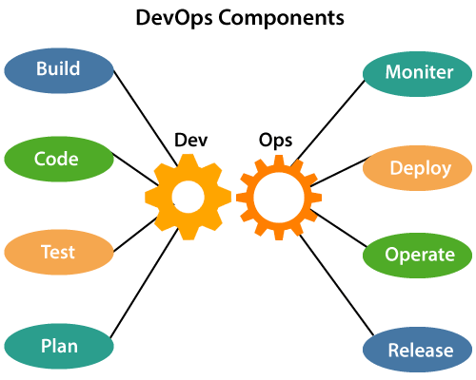

1. Build
Without DevOps, the cost of the consumption of the resources was evaluated based on the pre-defined individual usage with fixed hardware allocation. And with DevOps, the usage of cloud, sharing of resources comes into the picture, and the build is dependent upon the user's need, which is a mechanism to control the usage of resources or capacity.

2. Code
Many good practices such as Git enables the code to be used, which ensures writing the code for business, helps to track changes, getting notified about the reason behind the difference in the actual and the expected output, and if necessary reverting to the original code developed. The code can be appropriately arranged in files, folders, etc. And they can be reused.

3. Test
The application will be ready for production after testing. In the case of manual testing, it consumes more time in testing and moving the code to the output. The testing can be automated, which decreases the time for testing so that the time to deploy the code to production can be reduced as automating the running of the scripts will remove many manual steps.

4. Plan
DevOps use Agile methodology to plan the development. With the operations and development team in sync, it helps in organizing the work to plan accordingly to increase productivity.

5. Monitor
Continuous monitoring is used to identify any risk of failure. Also, it helps in tracking the system accurately so that the health of the application can be checked. The monitoring becomes more comfortable with services where the log data may get monitored through many third-party tools such as Splunk.

6. Deploy
Many systems can support the scheduler for automated deployment. The cloud management platform enables users to capture accurate insights and view the optimization scenario, analytics on trends by the deployment of dashboards.

7. Operate
DevOps changes the way traditional approach of developing and testing separately. The teams operate in a collaborative way where both the teams actively participate throughout the service lifecycle. The operation team interacts with developers, and they come up with a monitoring plan which serves the IT and business requirements.

8. Release
Deployment to an environment can be done by automation. But when the deployment is made to the production environment, it is done by manual triggering. Many processes involved in release management commonly used to do the deployment in the production environment manually to lessen the impact on the customers.

